SQL- ASSIGNMENT-1 (ITEMS AND PRODCUTS DATABASE)

Basics Questions:
- Create two Databases Name: Brands and Products
Ans: CREATE DATABASE BRANDS;
CREATE DATABASE PRODUCTS;
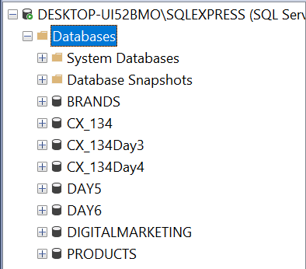

- Create two tables in SQL Server name as ITEMS_TABLE in Brands database and PRODUCT_TABLE in Products database.
Ans: CREATE TABLE ITEMS_TABLE (item_id int,
item_description varchar(MAX),
vendor_nos int, vendor_name varchar(MAX),
bottle_size int, bottle_price decimal(10,2));
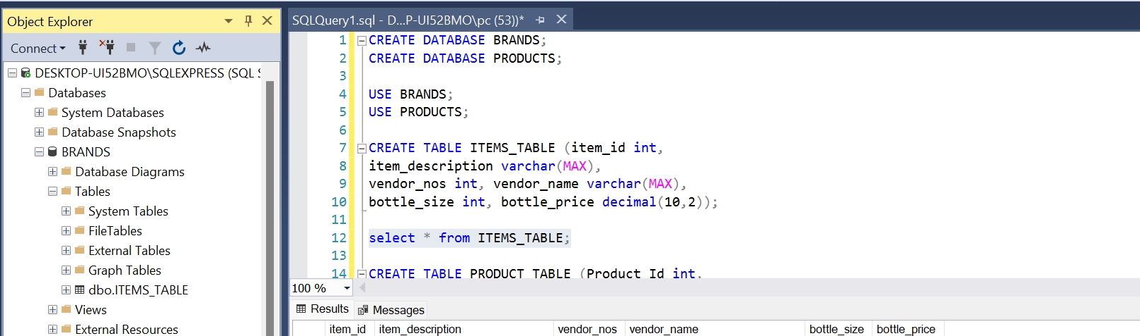

CREATE TABLE PRODUCT_TABLE (Product_Id int,
Country varchar(15),
Product varchar(MAX),
UnitsSold Float,
ManufacturingPrice int,
SalesPrice int, GrossSales int,
Sales int,COGS int,
Profit int, Date Date,
MonthNumber int, MonthName varchar(10),
Year int);
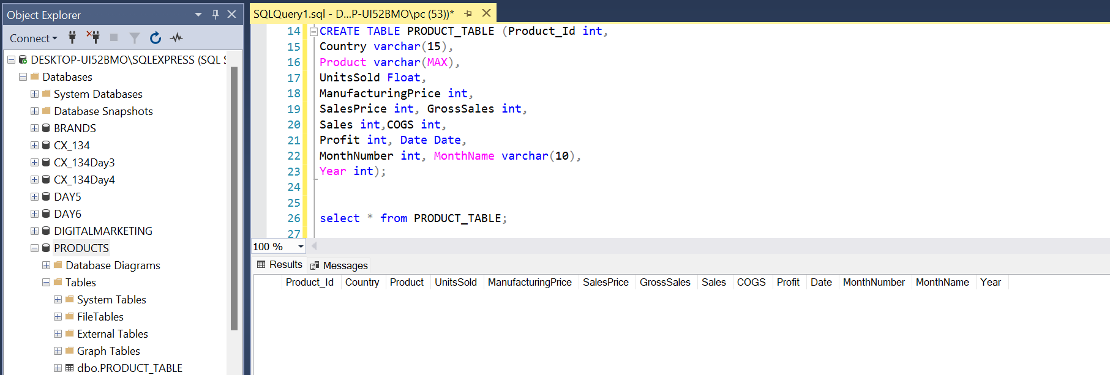

- After Creating both the tables Add records in that tables (records are available in ITEMS_TABLE Sheet and PRODUCTS_TABLE Sheet)
Ans: insert into ITEMS_TABLE values (1,'Travis Hasse Apple Pie', 305, 'Mhw Ltd', 750, 9.77),

insert into ITEMS_TABLE
values (2,'D aristi Xtabentun', 391, 'Anchor Distilling(preiss Imports)', 750, 14.12),
(3, 'Hiram Walker Peach Brandy', 370, 'Pernod Ricard Usa/austin Nichols', 1000, 6.5),
(4, 'Oak Cross Whisky', 305, 'Mhw Ltd', 750, 25.33),
(5, 'Uv Red(cherry) Vodka', 380, 'Phillips Beverage Company', 200, 1.97),
(6, 'Heaven Hill Old Style White Label', 259, 'Heaven Hill Distilleries Inc', 750, 6.37),
(7, 'Hyde Herbal Liqueur', 194, 'Fire Tail Brands Llc', 750, 5.06),
(8, 'Dupont Calvados Fine Reserve', 403, 'Robert Kacher Selections', 750, 23.61);
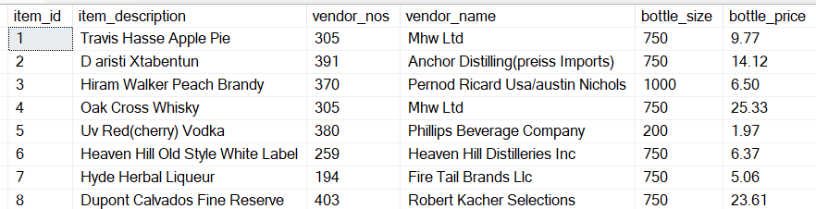

insert into PRODUCT_TABLE
values (1, 'Canada', 'Carretera', 1618.5, 3, 20, 32370, 32370, 16185, 16185, '2013-12-31', 1, 'January', 2014),
(2, 'Germany', 'Carretera', 1321, 3, 20, 26420, 26420, 13210, 13210, '2013-12-31', 1, 'January', 2015),
(3, 'France', 'Carretera', 2178, 3, 15, 32670, 32670, 21780, 10890, '2014-05-31', 6, 'June', 2016),
(4, 'Germany', 'Carretera', 888, 3, 15, 13320, 13320, 8880, 4440, '2014-05-31', 6, 'June',2017),
(5, 'Mexico', 'Carretera', 2470, 3, 15, 37050, 37050, 24700, 12350, '2014-05-31', 6, 'June', 2018),
(6, 'Germany', 'Carretera', 1513, 3, 350, 529550, 529550, 393380, 136170, '2014-11-30', 12, 'December', 2019),
(7, 'Germany', 'Montana', 921, 5, 15, 13815, 13815, 9210, 4605, '2014-02-28', 3, 'March', 2020),
(8, 'Canada', 'Montana', 2518, 5, 12, 30216, 30216, 7554, 22662, '2014-05-31', 6, 'June', 2021);
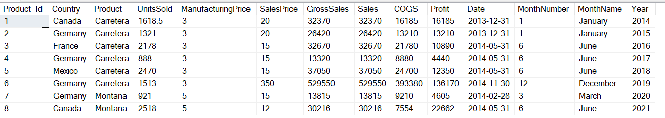

- Delete those product having the Units Sold 1618.5 , 888 and 2470.
Ans: DELETE FROM PRODUCT_TABLE
WHERE UnitsSold in (1618.5, 888, 2470);
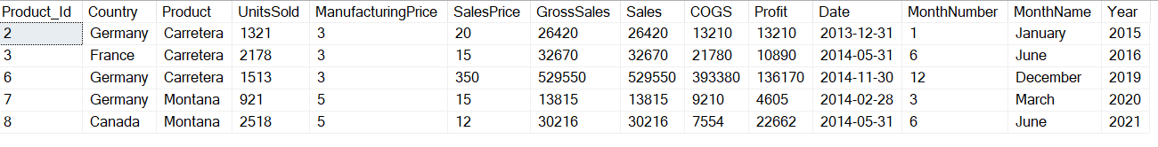

- Select all records from the ITEMS_TABLE table.
Ans: select * from ITEMS_TABLE;
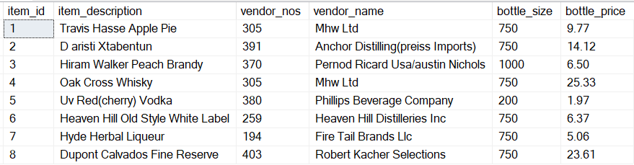

- Select the item_description and bottle_price for all items in the ITEMS_TABLE table.
Ans: SELECT item_description, bottle_size
from ITEMS_TABLE;
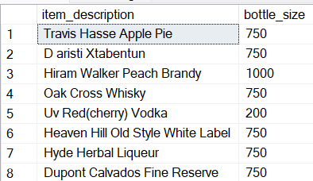

- Find the item_description and bottle_price of items where bottle_price is greater than 20.
Ans: SELECT item_description, bottle_price
from ITEMS_TABLE
where bottle_price > 20;
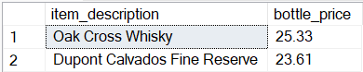
- Select Unique Country from the product_sales table
Ans: SELECT DISTINCT COUNTRY
FROM PRODUCT_TABLE;
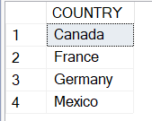
- Count the number of Countries in the product_sales table
Ans: SELECT COUNT(*) AS TOTALCOUNTRY
FROM PRODUCT_TABLE;
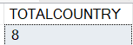
- How Many Countries are there which contain the sales price between 10 to 20
Ans: SELECT COUNT(COUNTRY) AS COUNTCOUNTRY
FROM PRODUCT_TABLE
WHERE SalesPrice BETWEEN 10 AND 20;
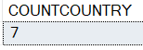

Intermediate Questions:
PRODUCTS_SALES_TABLE:-
- Find the Total Sale Price and Gross Sales
Ans: SELECT SUM(SALESPRICE) AS SUMSALESPRICE,
SUM(GROSSSALES) AS SUMGROSSSALES
FROM PRODUCT_TABLE;
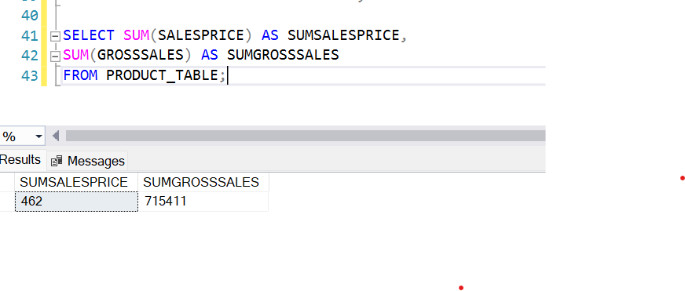
- In which year we have got the highest sales
Ans: SELECT SALES, YEAR
FROM PRODUCT_TABLE
WHERE SALES = (SELECT MAX(SALES) FROM PRODUCT_TABLE);
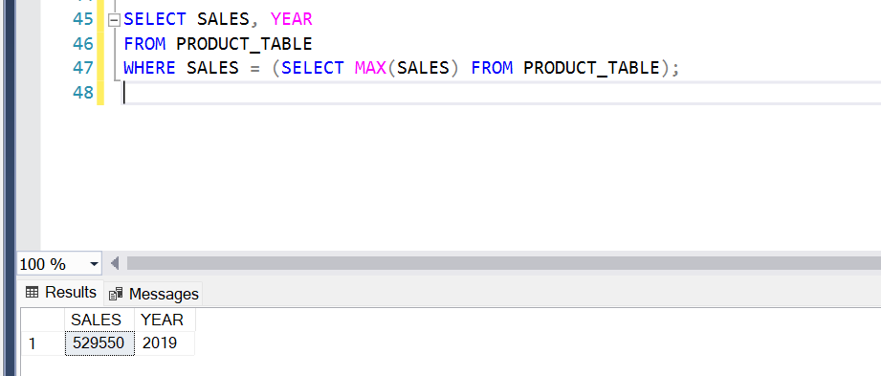

- Which Product having the sales of $ 37,050.00
Ans: SELECT PRODUCT
FROM PRODUCT_TABLE
WHERE SALES = (37050);
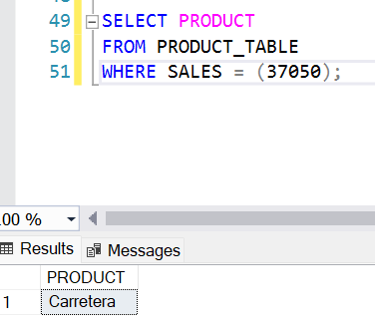
- Which Countries lies between profit of $ 4,605 to $ 22,662.00
Ans: SELECT Country
FROM PRODUCT_TABLE
WHERE PROFIT BETWEEN 4605 AND 22662;
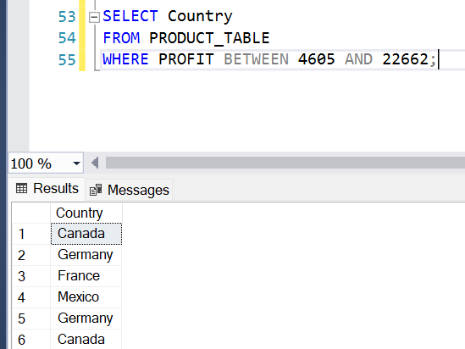
- Which Product Id having the Cogs of $ 24,700.00
Ans: SELECT PRODUCT_ID
FROM PRODUCT_TABLE
WHERE COGS = 24700;
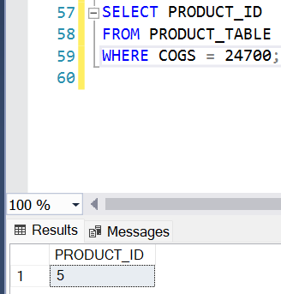
- Find the total Units Sold for each Country.
Ans: Select Country, Sum(UnitsSold) as TotalUnitsSold
From PRODUCT_TABLE
GROUP BY Country;
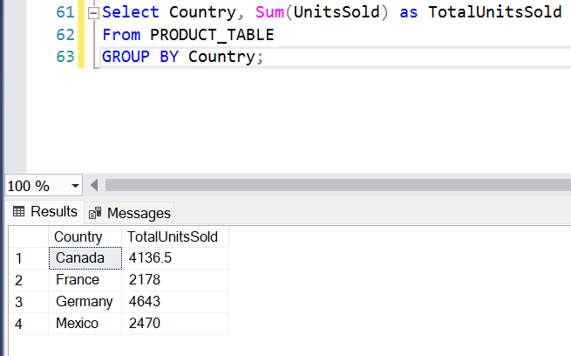
- Find the average sales for each country.
Ans: SELECT Country, AVG(Sales) as AVGSALES
FROM PRODUCT_TABLE
GROUP BY Country;
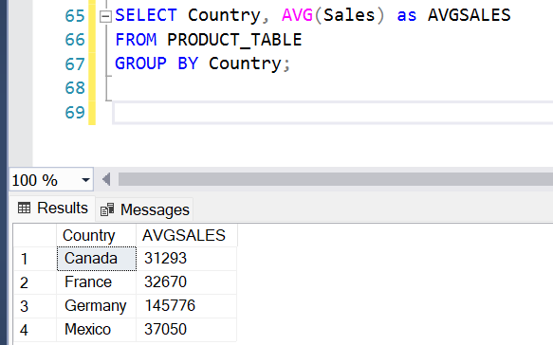
- Retrieve all products sold in 2014.
Ans: SELECT PRODUCT
FROM PRODUCT_TABLE
WHERE Year = (2014);
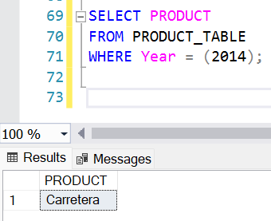
- Find the maximum Profit in the product_sales table.
Ans: SELECT Profit
FROM PRODUCT_TABLE
WHERE Profit = (SELECT MAX(Profit) FROM PRODUCT_TABLE);
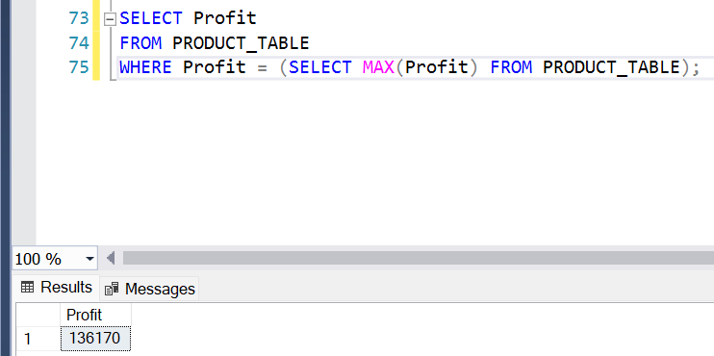

- Retrieve the records from product_sales where Profit is greater than the average Profit of all records.
Ans: SELECT * FROM PRODUCT_TABLE
WHERE Profit > (SELECT AVG(Profit) FROM PRODUCT_TABLE);
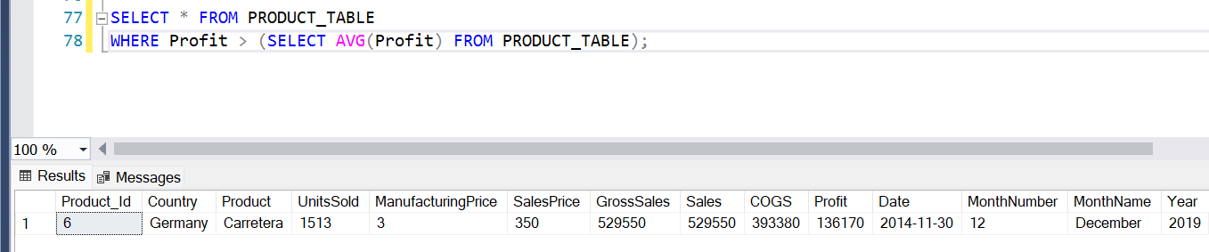

- Find the item_description having the bottle size of 750.
Ans: SELECT item_description
FROM ITEMS_TABLE
WHERE bottle_size = 750;
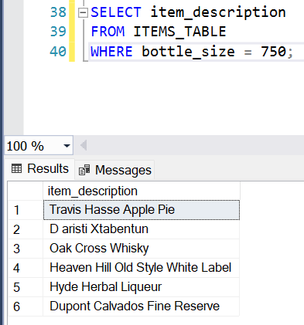

- Find the vendor Name having the vendor_nos 305 , 380 , 391.
Ans: SELECT vendor_name
FROM ITEMS_TABLE
WHERE vendor_nos IN (305,380,391);
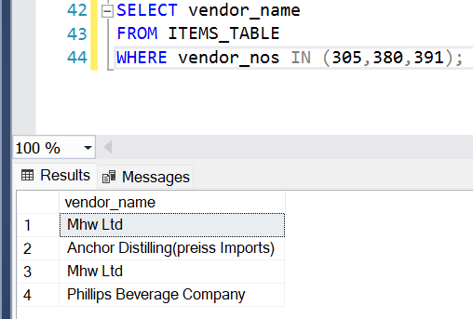

- What is total Bottle_price.
Ans: SELECT SUM(bottle_price) as TOTALBOTTLE_PRICE
FROM ITEMS_TABLE;
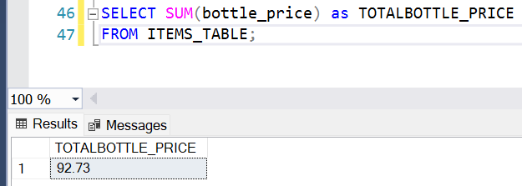

- Make Primary Key to Item_id
Ans: ALTER TABLE ITEMS_TABLE
ALTER COLUMN item_id int NOT NULL;

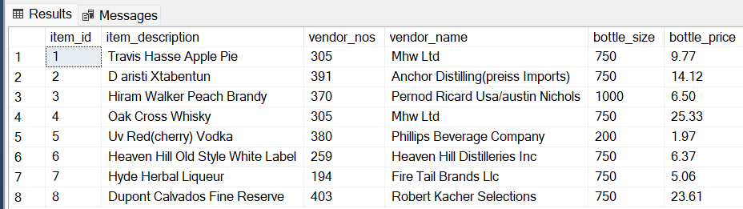

- Which item id having the bottle_price of $ 5.06
Ans: SELECT ITEM_ID
FROM ITEMS_TABLE
WHERE BOTTLE_PRICE = 5.06;
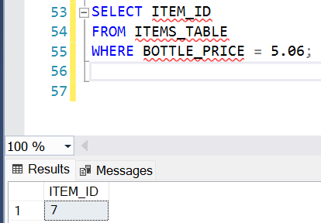

Advance Questions:

- Apply INNER , FULL OUTER , LEFT JOIN types on both the table.
Ans: A) Inner Join -
SELECT D1.*, D2.*
FROM BRANDS.DBO.ITEMS_TABLE AS D1
INNER JOIN
PRODUCTS1.DBO.PRODUCT_TABLE AS D2
ON D1.ITEM_ID = D2.Product_Id;
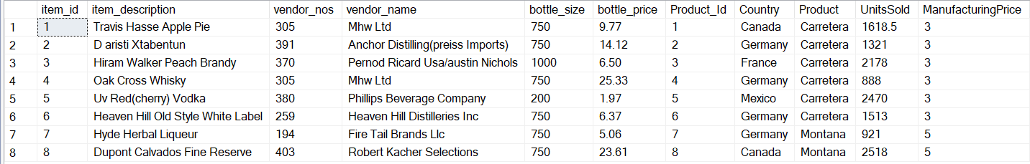
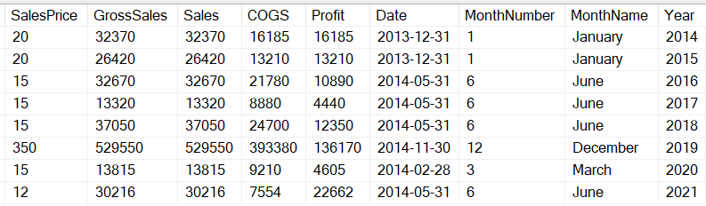
B) Full Outer Join –
SELECT
I.ITEM_ID,
I.ITEM_DESCRIPTION,
P.PRODUCT_ID,
P.PRODUCT
FROM BRANDS.DBO.ITEMS_TABLE AS I
FULL OUTER JOIN
PRODUCTS1.DBO.PRODUCT_TABLE AS P
ON I.ITEM_ID = P.Product_Id;
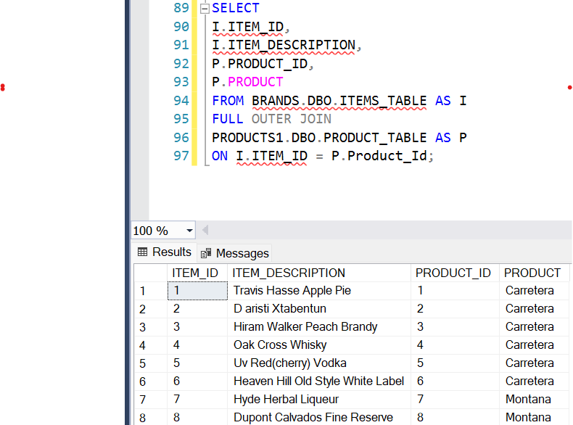
C) Left Join –
SELECT
I.ITEM_ID,
I.ITEM_DESCRIPTION,
P.PRODUCT_ID,
P.Product
FROM BRANDS.DBO.ITEMS_TABLE AS I
LEFT JOIN
PRODUCTS1.DBO.PRODUCT_TABLE AS P
ON I.ITEM_ID = P.Product_Id;
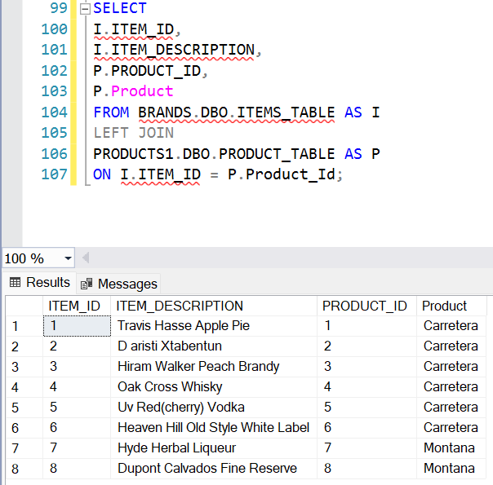

- Find the item_description and Product having the gross sales of 13,320.00
Ans: SELECT
I.ITEM_DESCRIPTION,
P.PRODUCT
FROM BRANDS.DBO.ITEMS_TABLE AS I
JOIN PRODUCTS1.DBO.PRODUCT_TABLE AS P
ON I.ITEM_ID = P.Product_Id
WHERE P.GrossSales = 13320;
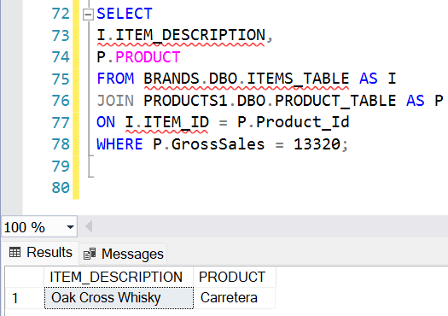

- Split the Item_description Column into Columns Item_desc1 and Item_desc2
Ans: SELECT
I.ITEM_ID,
LEFT(I.ITEM_DESCRIPTION,4) AS ITEM_DESC1,
SUBSTRING(I.ITEM_DESCRIPTION, 5, 4) AS ITEM_DESC2,
P.PRODUCT
FROM BRANDS.DBO.ITEMS_TABLE AS I
JOIN PRODUCTS1.DBO.PRODUCT_TABLE AS P
ON I.ITEM_ID = P.Product_Id;
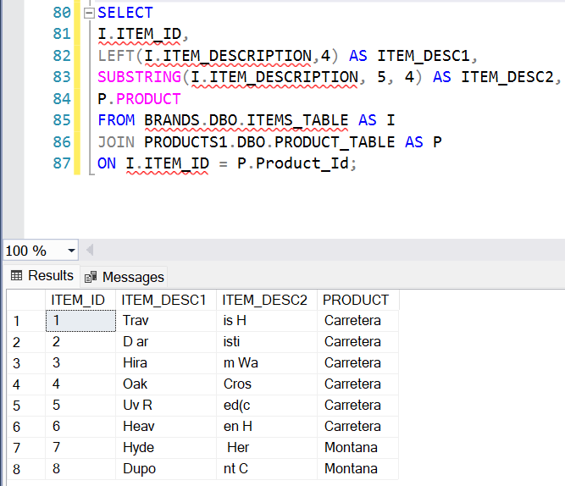

- Find the top 3 most expensive items in the ITEMS_TABLE table.
Ans: SELECT TOP 3
ITEM_ID,
ITEM_DESCRIPTION,
BOTTLE_PRICE
FROM BRANDS.DBO.ITEMS_TABLE
ORDER BY BOTTLE_PRICE DESC;
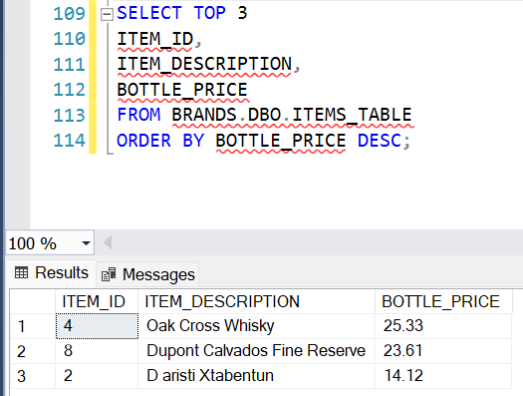

- Find the total Gross Sales and Profit for each Product in each Country.
Ans: SELECT PRODUCT, COUNTRY,
SUM(GROSSSALES) AS SUMGROSSSALES,
SUM(PROFIT) AS SUMPROFIT
FROM PRODUCT_TABLE
GROUP BY PRODUCT, COUNTRY;
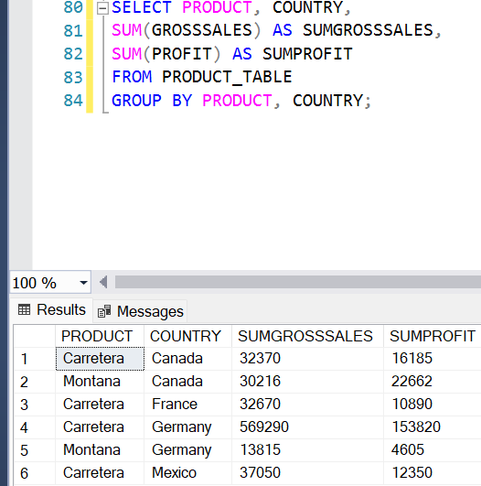

- Find the vendor_name and item_description of items with a bottle_size of 750 and bottle_price less than 10.
Ans: SELECT VENDOR_NAME, ITEM_DESCRIPTION
FROM ITEMS_TABLE
WHERE BOTTLE_SIZE = 750 AND BOTTLE_PRICE < 10;
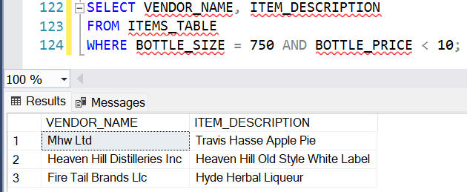

- Find the Product with the highest Profit in 2019.
Ans: SELECT TOP 1
PRODUCT,
PROFIT,
YEAR
FROM PRODUCT_TABLE
WHERE YEAR = 2019
ORDER BY Profit DESC;
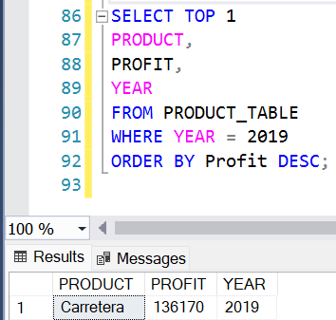

- Retrieve the Product_Id and Country of all records where the Profit is at least twice the COGS.
Ans: SELECT PRODUCT_ID,
COUNTRY
FROM PRODUCTS1.DBO.PRODUCT_TABLE
WHERE Profit >= 2*COGS;
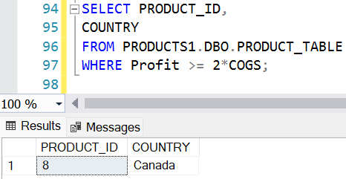

- Find the Country that had the highest total Gross Sales in 2018.
Ans: SELECT TOP 1
COUNTRY,
SUM(GROSSSALES) AS TOTAL_GROSSSALES
FROM PRODUCTS1.DBO.PRODUCT_TABLE
WHERE YEAR = 2018
GROUP BY COUNTRY
ORDER BY TOTAL_GROSSSALES DESC;
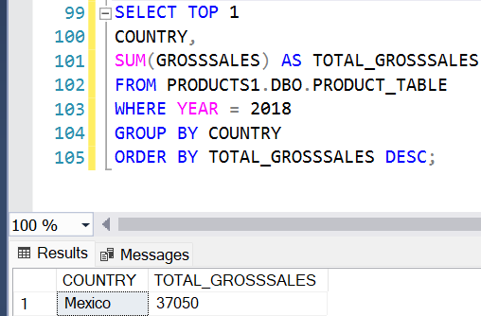

- Calculate the total Sales for each Month Name across all years.
Ans: SELECT MONTHNAME,
SUM(GROSSSALES) AS TOTAL_SALES
FROM PRODUCTS1.DBO.PRODUCT_TABLE
GROUP BY MonthName
ORDER BY DATEPART(MONTH, CAST('01' + MONTHNAME + '2000' AS DATETIME));
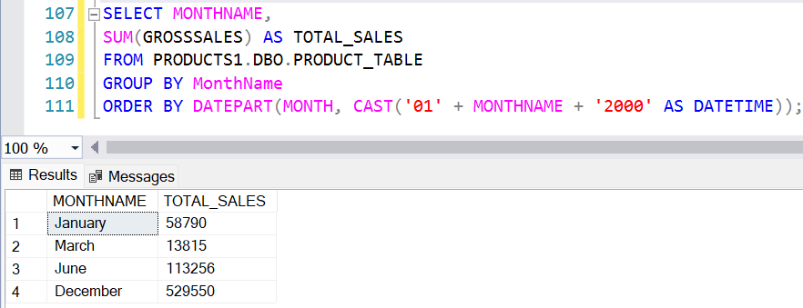

- List the item_description and vendor_name for items whose vendor_nos exists more than once in the ITEMS_TABLE table.
Ans: SELECT
ITEM_DESCRIPTION,
VENDOR_NAME,
VENDOR_NOS
FROM BRANDS.DBO.ITEMS_TABLE
WHERE VENDOR_NOS IN(
SELECT VENDOR_NOS
FROM BRANDS.DBO.ITEMS_TABLE
GROUP BY VENDOR_NOS
HAVING COUNT(*) > 1);
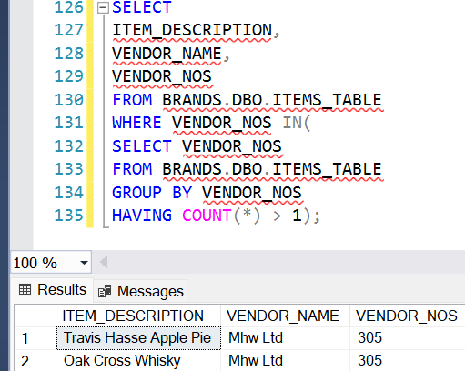

- Find the average Manufacturing Price for Product in each Country and only include those Country and Product combinations where the average is above 3.
Ans: SELECT
COUNTRY,
PRODUCT,
AVG(MANUFACTURINGPRICE) AS AVG_MANUFACTURINGPRICE
FROM PRODUCTS1.DBO.PRODUCT_TABLE
GROUP BY COUNTRY, PRODUCT HAVING AVG(MANUFACTURINGPRICE) > 3;
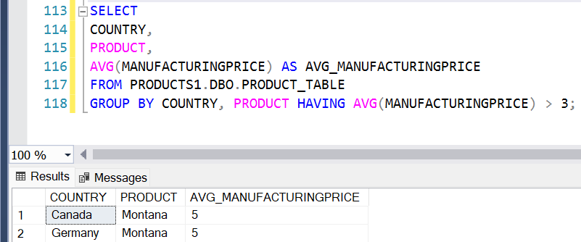

Super-Advance Questions:
- Find the item_description and bottle_price of items that have the same vendor_name as items with Item_Id 1.
Ans: SELECT ITEM_DESCRIPTION, BOTTLE_PRICE
FROM BRANDS.DBO.ITEMS_TABLE
WHERE VENDOR_NAME = (SELECT VENDOR_NAME
FROM BRANDS.DBO.ITEMS_TABLE
WHERE ITEM_ID = 1);
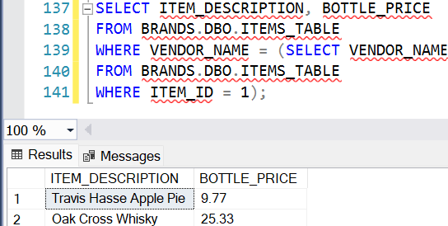

- Create a stored procedure to retrieve all records from the ITEMS_TABLE table where bottle_price is greater than a given value.
Ans: CREATE PROCEDURE GETITEMSABOVEPRICE @MINPRICE DECIMAL(10,2)
AS BEGIN
SET NOCOUNT ON;
SELECT ITEM_ID,
ITEM_DESCRIPTION, VENDOR_NOS,
VENDOR_NAME, VENDOR_NAME,
BOTTLE_SIZE, BOTTLE_PRICE
FROM BRANDS.DBO.ITEMS_TABLE
WHERE BOTTLE_PRICE > @MINPRICE;
END;
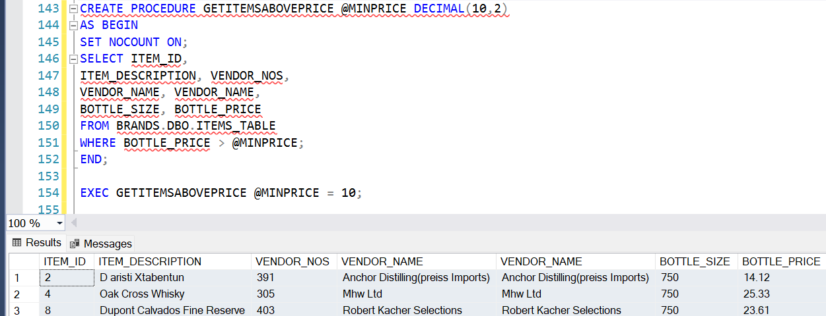

- Create a stored procedure to insert a new record into the product_sales table.
Ans: CREATE TABLE DBO.PRODUCT_SALES (
SALE_ID INT IDENTITY(1,1) PRIMARY KEY,
PRODUCT_ID INT NOT NULL,
QUANTITY INT NOT NULL,
SALE_DATE DATE NOT NULL,
TOTAL_AMOUNT DECIMAL(10,2) NOT NULL);

CREATE PROCEDURE INSERTPRODUCTSALES
@PRODUCTID INT,
@QUANTITY INT,
@SALEDATE DATE,
@TOTALAMOUNT DECIMAL(10,2)
AS BEGIN
SET NOCOUNT ON;
INSERT INTO DBO.PRODUCT_SALES
(PRODUCT_ID, QUANTITY, SALE_DATE, TOTAL_AMOUNT)
VALUES (@PRODUCTID, @QUANTITY, @SALEDATE, @TOTALAMOUNT);
SELECT SCOPE_IDENTITY() AS NEWSALEID;
END;

EXEC INSERTPRODUCTSALES
@PRODUCTID = 101,
@QUANTITY = 5,
@SALEDATE = '2025-08-20',
@TOTALAMOUNT = 250.00;
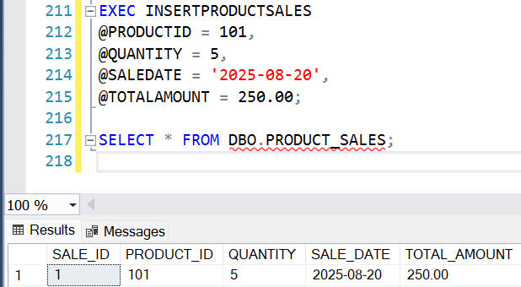

- Create a trigger to automatically update the Gross_Sales field in the product_sales table whenever Units_Sold or Sale_Price is updated.
Ans: CREATE TRIGGER TRG_UPDATEGROSSSALES
ON PRODUCT_TABLE
AFTER UPDATE
AS
BEGIN
SET NOCOUNT ON;
UPDATE P
SET P.GROSSSALES = I.UNITSSOLD * I.SALESPRICE
FROM PRODUCT_TABLE P
INNER JOIN INSERTED I ON P.Product_Id = I.Product_Id;
END;
/*EXECUTION WITH VALUES*/
INSERT INTO PRODUCT_TABLE
(Product_Id, Country, Product, UnitsSold, ManufacturingPrice, SalesPrice, GrossSales, Sales, Profit, Date, MonthNumber, MonthName, Year)
VALUES(9, 'FRANCE', 'MONTANA', 2745, 5, 20, 25946, 31584, 21564, '2014-06-15', 6, 'JUNE', 2022);

SELECT * FROM PRODUCT_TABLE;

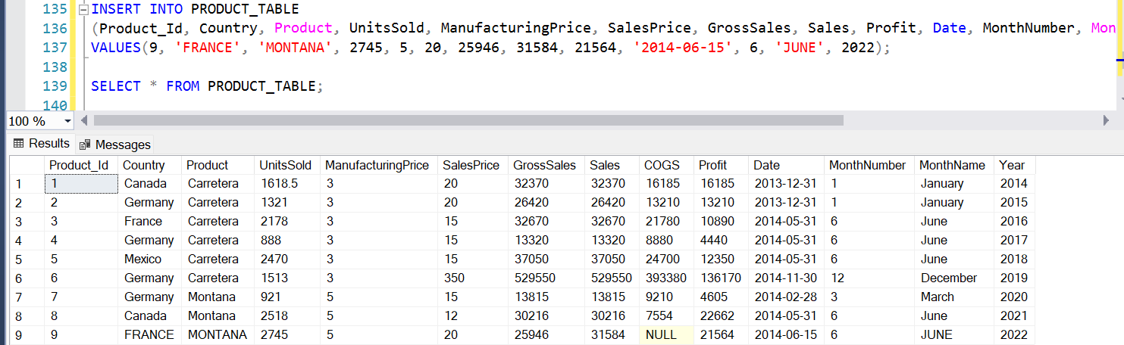

SELECT PRODUCT_ID, UNITSSOLD,SALESPRICE, GROSSSALES FROM PRODUCT_TABLE
WHERE PRODUCT_ID = 1;
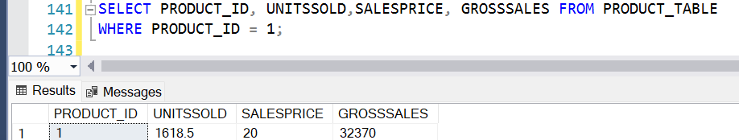
UPDATE PRODUCT_TABLE
SET SalesPrice = 60
WHERE Product_Id = 1;
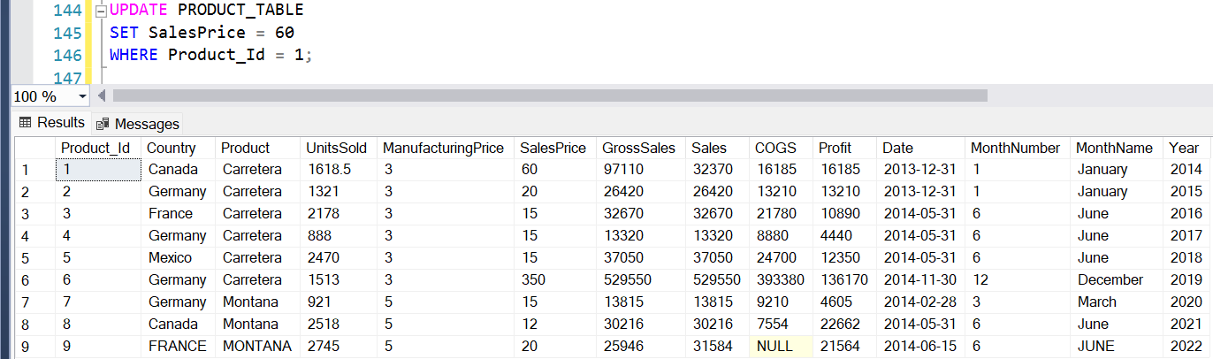
SELECT PRODUCT_ID, UNITSSOLD, SALESPRICE, GROSSSALES
FROM PRODUCT_TABLE
WHERE Product_Id = 1;
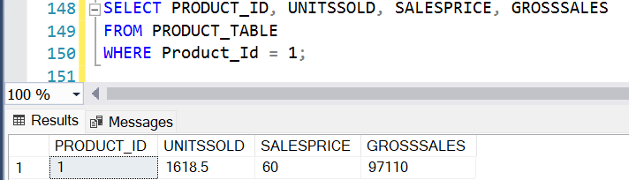
UPDATE PRODUCT_TABLE
SET UnitsSold = 15
WHERE Product_Id = 1;
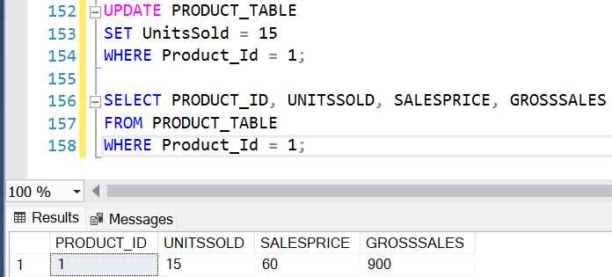
Answers: Grosssales = 0, 600 and 900.

- Write a query to find all item_description in the ITEMS_TABLE table that contain the word "Whisky" regardless of case.
Ans: SELECT ITEM_DESCRIPTION
FROM ITEMS_TABLE
WHERE ITEM_DESCRIPTION LIKE '%WHISKY%';
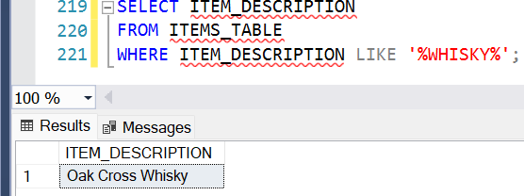

- Write a query to find the Country and Product where the Profit is greater than the average Profit of all products.
Ans: SELECT COUNTRY, PRODUCT, PROFIT
FROM PRODUCT_TABLE
WHERE Profit > (SELECT AVG(PROFIT) FROM PRODUCT_TABLE);
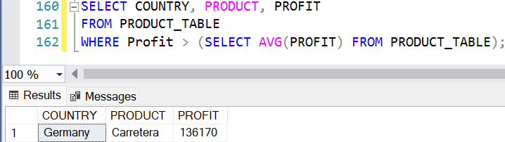

- Write a query to join the ITEMS_TABLE and product_sales tables on a common field (e.g., vendor_nos) and select relevant fields from both tables.
Ans: SELECT
I.VENDOR_NOS,
I.ITEM_DESCRIPTION,
I.VENDOR_NAME,
I.BOTTLE_SIZE,
I.BOTTLE_PRICE,
PS.PRODUCT_ID,
PS.COUNTRY,
PS.PRODUCT,
PS.UNITSSOLD,
PS.SALESPRICE,
PS.SALES,
PS.PROFIT
FROM BRANDS.DBO.ITEMS_TABLE I
INNER JOIN PRODUCTS1.DBO.PRODUCT_TABLE PS
ON I.item_id = PS.Product_Id;
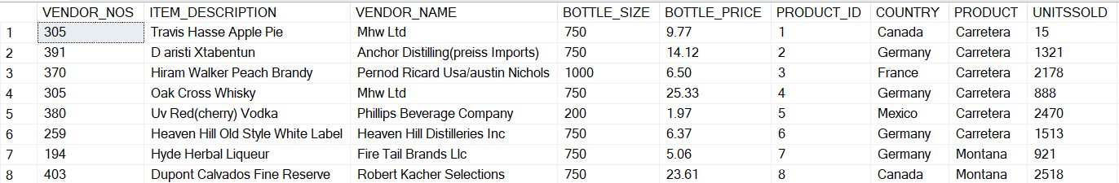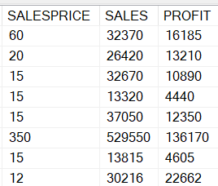

- Write a query to combine item_description and vendor_name into a single string for each record in the ITEMS_TABLE table, separated by a hyphen.
Ans: SELECT
ITEM_DESCRIPTION + ' - ' + VENDOR_NAME AS ITEM_VENDOR
FROM BRANDS.DBO.ITEMS_TABLE;
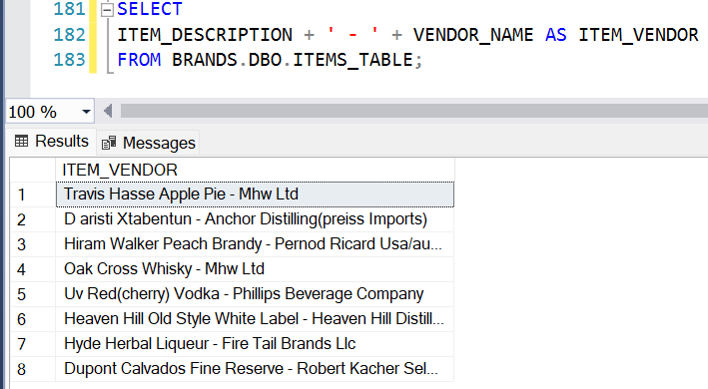

- Write a query to display the bottle_price rounded to one decimal place for each record in the ITEMS_TABLE table.
Ans: SELECT
ITEM_ID, ITEM_DESCRIPTION, VENDOR_NAME,
ROUND(BOTTLE_PRICE, 1) AS ROUNDED_BOTTLE_PRICE
FROM BRANDS.DBO.ITEMS_TABLE;
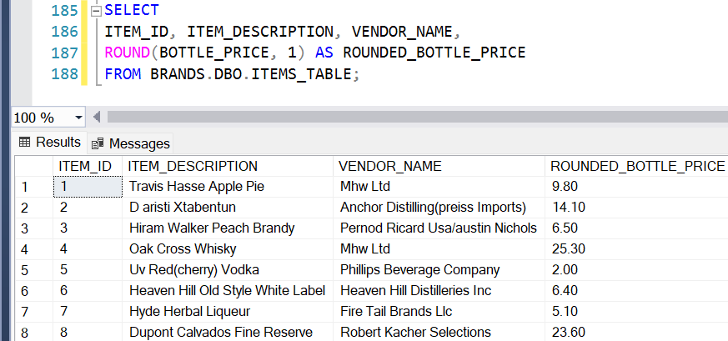

- Write a query to calculate the number of days between the current date and the Date field for each record in the product_table table.
Ans: SELECT
PRODUCT_ID, COUNTRY,
PRODUCT, DATE,
DATEDIFF(DAY, DATE, GETDATE()) AS DAYS_DIFFERENCE
FROM PRODUCTS1.DBO.PRODUCT_TABLE;
